3.3.3.1 Special request, Advice October 2013

ECOREGION Barents and Greenland seas
SUBJECT Status and harvest potential of the harp seal stocks in the Greenland Sea
and the White Sea/Barents Sea, and of the hooded seal stock in the
Greenland Sea

Advice summary

The estimates of harp seal abundance in the Greenland Sea and the White Sea/Barents Sea continue to show an increase, and advice on different catch scenarios is provided for both stocks. The hooded seal stock in the Greenland Sea is well below 30% of the largest estimated population size, and ICES advises that no catch be allowed from this stock.

Based on the experience from the Northwest Atlantic, ICES advises that future catch scenarios are explored over a 15-year time horizon, rather than the current ten-year period.

Request

The Norwegian Royal Ministry of Fisheries and Coastal Affairs requested ICES to:

Assess the status and harvest potential of harp seal stocks in the Greenland Sea and White Sea/Barents Sea and of the hooded seal stocks in the Greenland Sea, and

Assess the impact on the harp seal stocks in the Greenland Sea and the White Sea/Barents Sea of an annual harvest of:

- Current harvest levels,
- Sustainable catches (defined as the fixed annual catches that stabilizes the future age 1+ population),
- Catches that would reduce the population over a 10-year period in such a manner that it would remain above a level of 70% of current level with 80% probability.

ICES advice

The advice is structured as an update of relevant parts of the advice provided by ICES in 2011 (ICES, 2011a).

The request concerns three seal stocks: Greenland Sea harp seals, White Sea/Barents Sea harp seals, and Greenland Sea hooded seals. The distribution of the stocks is shown in Figure 3.3.3.1.1.
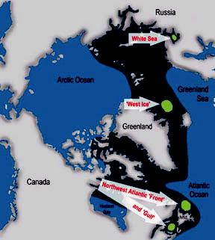

Figure 3.3.3.1.1 Locations of North Atlantic harp and hooded seal stocks. Green spots indicate the whelping and moulting areas for the White Sea (also called the East Ice) stock of harp seals, the Greenland Sea (or West Ice) stocks of harp and hooded seals, and the northwest Atlantic (Front and Gulf areas) stocks of harp and hooded seals. Dark blue indicates the entire distributional area.

ICES Advice 2013, Book 3 | 1

Greenland Sea harp seals

The estimated size of the Greenland Sea harp seal stock in 2013 is 627 410 (470 540–784 280) ¹ animals, comprising 534 400 (379 200–689 600) age 1+ seals and 93 010 (70 210–115 800) young of the year. In 2013, the existing population model incorporated historical reproductive rate data and the new pup production estimate for 2012. Updating the time series resulted in a reduced estimated growth rate and smaller stock than that reported in 2011. However, the revised 2013 estimate is still the largest in the time-series.

The Greenland Sea harp seal stock is considered to be ‘data-rich’ and estimated to be above the N₇₀ level (i.e., more than 70% of the known maximum stock size measured). Thus, it is appropriate to provide catch advice using the assessment model.

The analysis of catch options indicates the following:

- If the recent average catch (2008–2012) of 5941 animals (59.9% pups) is maintained, then the age 1+ population is expected to increase by 21% over the next ten years.

- The equilibrium catch levels are 20 429 animals (of which 59.9% are pups) or 14 600 (100% age 1+ animals).

- Annual catches that would reduce the population over a 10-year period but would still maintain the stock above 70% of the current level with 80% probability are 30 988 animals (of which 59.9% are pups) or 21 270 (100% age 1+ animals).

The current size of the Greeland Sea harp seal stock (i.e. 627 410 animals) is estimated to be at a record-high. N_{lim} (equal to 30% of the largest estimated population size) is estimated at 188 223 animals. ICES advises that this estimate of N_{lim} be regarded as the minimum sustainable size of the Greenland Sea harp seal stock and that below this stock size there should be no catch.

ICES regards 70% of the unexploited population size as the stock size associated with the maximum sustainable long-term average catch. This stock size (N₇₀) is estimated at 439 187 animals. The maximum sustainable long-term average catch is about 20 400 animals (of which 59.9% are pups) annually.

Simulation work conducted on the Northwest Atlantic harp seal population suggests that catches should be projected over a period of at least 15 years to determine their impact on the population. Therefore, ICES advises that future catch scenarios are explored over a 15-year period, rather than the current ten-year period. This advice applies to all of the seal populations considered by ICES.

White Sea/Barents Sea harp seals

No new data on stock size or number of pups has been available since the last advice was provided in 2011. The same model was run with two more projected years. The estimated size of the White Sea/Barents Sea stock in 2013 is 1 419 800 (1 266 910–1 572 690) animals. The stock is estimated to be above the N₇₀ level. The 2013 predicted pup production is estimated at 198 800 (177 483–220 117) animals. Since 2004 aerial surveys have shown pup production estimates that are much lower than estimates obtained from surveys flown between 1998 and 2004. This could be due to a change in fecundity and/or changes in survival.

New pup surveys were conducted in 2013. The data are currently being analysed and it is anticipated that the estimates will be available in 2014. Taking into account the uncertainties in the trend of pup production for this population, ICES recommends that the results should be reviewed as soon as possible.

The original population model for the White Sea/Barents Sea harp seal stock provides a poor fit to the pup production survey data. Based on the lack of recent data on reproduction rates and the previously agreed criteria ², the Barents Sea/White Sea harp seal stock is considered to be ‘data-poor’. Therefore, the potential biological removal (PBR) was also calculated. However, catch advice is provided using the modified assessment model, which is more conservative than the PBR approach.

- If the recent average catch (2008–2012) of 2732 animals (97.6% pups) is maintained, the stock is expected to increase by 13% over ten years. However, ICES notes that the catches in 2009–2012 have been 200 animals or lower, and the actual stock increase rate will be higher if catches continue at this level.

- Sustainable catches are 32 736 animals (of which 97.6% are pups) or 17 400 (100% age 1+ animals).

- Lower and upper bound in a 95% confidence interval
- Three surveys within the past 15 years; one survey within the past five years; recent data on reproductive rates.

2 ICES Advice 2013, Book 3
- Annual catches that would reduce the population over a ten-year period but would still maintain the stock above 70% of the current level with 80% probability are 49 775 animals (of which 97.6% are pups) or 26 650 (100% age 1+ animals).

Greenland Sea hooded seals

A population model, incorporating a reproduction rate of F = 0.7, produced a 2013 stock estimate of 68 820 age 1+ animals and 14 010 pups. The estimated total stock size of hooded seals in the Greenland Sea is therefore 82 830 animals (SE = 8028). All model runs indicate a declining population which is currently well below N₃₀ (30% of the largest observed population size).

- Following the precautionary harvest strategy previously developed by ICES and given that the current stock size of 82 830 animals is well below N_{lim} (233 700 animals), ICES recommends that no harvest be allowed from the Greenland Sea hooded seal stock.

Background

Greenland Sea harp seals

State of stock/exploitation

The estimated adult population is at its highest level since the 1940s. Based on the population model using mark– recapture data (1983–1991) and recent aerial survey data, the stock in 2013 was estimated at 627 410 (470 540– 784 280) seals. This is down slightly, but not significantly from the 2007 estimate of 649 566 (SE = 138 028) seals. The Greenland Sea harp seal stock is considered data rich, and above the N₇₀ level.

The recent average annual catch (2008–2012) is 5941. Total catches in 2012 were 5593 harp seals (including 3740 pups), whereas 16 033 harp seals were taken in 2013 (including 13 911 pups; Table 3.3.3.1.1). These catches represented 22% and 54% of the 2012 and 2013 TAC ³ which was set at 25 000 age 1+ animals (where two pups balance one age 1+ animal). Russia has not participated in this hunt since 1994.

Population estimates

In the period 18 March to 1 April 2012 IMR conducted aerial surveys in the Greenland Sea pack-ice (the West Ice), to assess the pup production of the Greenland Sea populations of harp and hooded seals. The total pup production estimate obtained for harp seals was 89 590 (SE = 12 310; Table 3.3.3.1.2). This estimate is slightly, but not significantly lower than estimates obtained during similar surveys of the area in 2002 and 2007.

The population model is similar to the model used to assess the abundance of the White Sea/Barents Sea harp seal population. The model uses pregnancy rates from a Russian data-set for 1959–1991 and Norwegian data for 2008 and 2009 (Table 3.3.3.1.3; ICES, 2011b). In periods where data are missing, a linear transition between estimates was assumed. The model also incorporates a maturity curve based upon data collected in 1959–1990 and in 2009 (Table 3.3.3.1.4). A linear transition between the two curves was assumed.

The estimated population sizes are presented in Table 3.3.3.1.5, along with the parameters for the priors used in the model. The model indicates an increasing population from the 1970s up to the present time (Figure 3.3.3.1.2).However, the population model had difficulty in capturing the dynamics of the pup production estimates. The predicted population trajectories from the model are driven by the mark–recapture estimates of pup production from the 1980s and early 1990s. There is considerable uncertainty associated with these estimates.

The estimated size of the Greenland Sea harp seal stock in 2013 is 627 410 (470 540–784 280) animals, comprising 534 400 (379 200–689 600) age 1+ seals, and 93 010 (70 210–115 800) young of the year. In 2013, the existing population model incorporated historical reproductive rate data together with the new pup production estimate for 2012. Updating the time-series resulted in a reduced estimated growth rate and smaller stock than that reported in 2011. However, the revised 2013 estimate is still the largest in the time-series.

³ The TAC is the estimated level of removals that would reduce the population by less than 30% with a probability of more than 80% over the next ten-year period. The quota has been implemented such that parts of, or the whole quota, could be taken as weaned pups, assuming two pups equaled one age 1+ animal.

ICES Advice 2013, Book 3 | 3

Catch options

The projected stock sizes at different catch options are given in Table 3.3.3.1.6.

At current catch levels, the model indicates an increase of 21% in the age 1+ population over the next ten years. The equilibrium catch level is 14 600 (100% age 1+ animals). A catch level of 21 270 animals (100% age 1+) is estimated to reduce the population but keep it above N₇₀ with a probability of 80%.
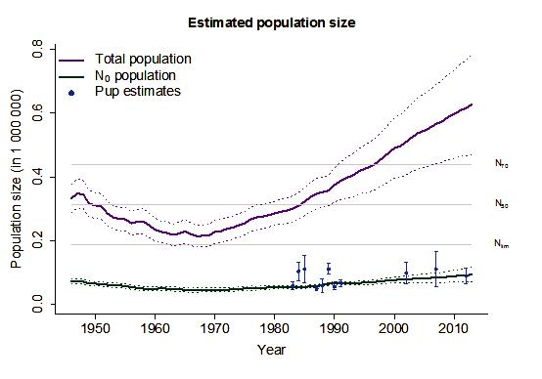

Figure 3.3.3.1.2 Modelled population trajectories for Greenland Sea harp seal pups and total population (full lines) and 95% confidence intervals (dashed lines). N₇₀, N₅₀, and N_{lim} denote the 70%, 50%, and 30% of the estimated maximum population size, respectively.”

Table 3.3.3.1.1 Catches of harp seals in the Greenland Sea (“West Ice”) from 1946 through 2013ª. Totals include catches for scientific purposes.

Year | Norwegian catches |  |  | Russian catches |  |  |  | Total catches
 | Pups | 1 year | Total | pups | 1 year | Total | Pups |  | 1 year |  | Total
 |  | and older |  |  | and older |  |  |  | and older
1946–50 | 26606 | 9464 | 36070 | - | - | - | 26606 |  | 9464 |  | 36070
1951–55 | 30465 | 9125 | 39590 | - | - | ₋b | 30465 |  | 9125 |  | 39590
1956–60 | 18887 | 6171 | 25058 | 1148 | 1217 | 2365^{b} | 20035 |  | 7388 |  | 27423
1961–65 | 15477 | 3143 | 18620 | 2752 | 1898 | 4650 | 18229 |  | 5041 |  | 23270
1966–70 | 16817 | 1641 | 18458 | 1 | 47 | 48 | 16818 |  | 1688 |  | 18506
1971 | 11149 | 0 | 11149 | - | - | - | 11149 |  | 0 |  | 11149
1972 | 15100 | 82 | 15182 | - | - | - | 15100 |  | 82 |  | 15182
1973 | 11858 | 0 | 11858 | - | - | - | 11858 |  | 0 |  | 11858
1974 | 14628 | 74 | 14702 | - | - | - | 14628 |  | 74 |  | 14702
1975 | 3742 | 1080 | 4822 | 239 | 0 | 239 | 3981 |  | 1080 |  | 5061
1976 | 7019 | 5249 | 12268 | 253 | 34 | 287 | 7272 |  | 5283 |  | 12555
1977 | 13305 | 1541 | 14846 | 2000 | 252 | 2252 | 15305 |  | 1793 |  | 17098
1978 | 14424 | 57 | 14481 | 2000 | 0 | 2000 | 16424 |  | 57 |  | 16481
1979 | 11947 | 889 | 12836 | 2424 | 0 | 2424 | 14371 |  | 889 |  | 15260
1980 | 2336 | 7647 | 9983 | 3000 | 539 | 3539 | 5336 |  | 8186 |  | 13522
1981 | 8932 | 2850 | 11782 | 3693 | 0 | 3693 | 12625 |  | 2850 |  | 15475
1982 | 6602 | 3090 | 9692 | 1961 | 243 | 2204 | 8563 |  | 3333 |  | 11896
4 |  |  |  |  |  |  | ICES Advice 2013, Book 3
Year | Norwegian catches |  |  | Russian catches |  |  |  | Total catches
 | Pups | 1 year | Total | pups | 1 year | Total | Pups |  | 1 year |  | Total
 |  | and older |  |  | and older |  |  |  | and older
1983 | 742 | 2576 | 3318 | 4263 | 0 | 4263 | 5005 |  | 2576 |  | 7581
1984 | 199 | 1779 | 1978 | - | - | - | 199 |  | 1779 |  | 1978
1985 | 532 | 25 | 557 | 3 | 6 | 9 | 535 |  | 31 |  | 566
1986 | 15 | 6 | 21 | 4490 | 250 | 4740 | 4505 |  | 256 |  | 4761
1987 | 7961 | 3483 | 11444 | - | 3300 | 3300 | 7961 |  | 6783 |  | 14744
1988 | 4493 | 5170 | 9663^{c} | 7000 | 500 | 7500 | 11493 |  | 5670 |  | 17163
1989 | 37 | 4392 | 4429 | - | - | - | 37 |  | 4392 |  | 4429
1990 | 26 | 5482 | 5508 | 0 | 784 | 784 | 26 |  | 6266 |  | 6292
1991 | 0 | 4867 | 4867 | 500 | 1328 | 1828 | 500 |  | 6195 |  | 6695
1992 | 0 | 7750 | 7750 | 590 | 1293 | 1883 | 590 |  | 9043 |  | 9633
1993 | 0 | 3520 | 3520 | - | - | - | 0 |  | 3520 |  | 3520
1994 | 0 | 8121 | 8121 | 0 | 72 | 72 | 0 |  | 8193 |  | 8193
1995 | 317 | 7889 | 8206 | - | - | - | 317 |  | 7889 |  | 8206
1996 | 5649 | 778 | 6427 | - | - | - | 5649 |  | 778 |  | 6427
1997 | 1962 | 199 | 2161 | - | - | - | 1962 |  | 199 |  | 2161
1998 | 1707 | 177 | 1884 | - | - | - | 1707 |  | 177 |  | 1884
1999 | 608 | 195 | 803 | - | - | - | 608 |  | 195 |  | 803
2000 | 6328 | 6015 | 12343 | - | - | - | 6328 |  | 6015 |  | 12343
2001 | 2267 | 725 | 2992 | - | - | - | 2267 |  | 725 |  | 2992
2002 | 1118 | 114 | 1232 | - | - | - | 1118 |  | 114 |  | 1232
2003 | 161 | 2116 | 2277 |  |  |  | 161 |  | 2116 |  | 2277
2004 | 8288 | 1607 | 9895 |  |  |  | 8288 |  | 1607 |  | 9895
2005 | 4680 | 2525 | 7205 |  |  |  | 4680 |  | 2525 |  | 7205
2006 | 2343 | 961 | 3304 |  |  |  | 2343 |  | 961 |  | 3304
2007 | 6188 | 1640 | 7828 |  |  |  | 6188 |  | 1640 |  | 7828
2008 | 744 | 519 | 1263 |  |  |  | 744 |  | 519 |  | 1263
2009 | 5177 | 2918 | 8035 |  |  |  | 5177 |  | 2918 |  | 8035
2010 | 2823 | 1855 | 4678 |  |  |  | 2823 |  | 1855 |  | 4678
2011 | 5361 | 4773 | 10134 |  |  |  | 5361 |  | 4773 |  | 10134
2012 | 3740 | 1853 | 5593 | - | - | - | 3740 |  | 1853 |  | 5593
2013 | 13911 | 2122 | 16033 | - | - | - | 13911 |  | 2122 |  | 16033

- The period 1946–1970 shows only five-year averages.
- For 1955, 1956, and 1957 Soviet catches of harp and hooded seals were reported at 3900, 11 600, and 12 900, respectively. These catches are not included.
- Including 1431 pups and one adult caught by a ship which was lost.

Table 3.3.3.1.2 | Survey estimates of Greenland Sea harp seal pup production.
 |  | YEAR | ESTIMATE | C.V.
 |  | 1983 | 58 539 | 0.10
 |  | 1984 | 103 250 | 0.15
 |  | 1985 | 111 084 | 0.20
 |  | 1987 | 49 970 | 0.08
 |  | 1988 | 58 697 | 0.18
 |  | 1989 | 110 614 | 0.08
 |  | 1990 | 55 625 | 0.08
 |  | 1991 | 67 271 | 0.08
 |  | 2002 | 98 500 | 0.18
 |  | 2007 | 110 530 | 0.25
 |  | 2012 | 89 590 | 0.137

ICES Advice 2013, Book 3 | 5
Table 3.3.3.1.3 | Reproduction rates, F_{t}, for harp seals in the Greenland Sea.
 |  |  | Year | Pregnancy rate | Standard
 |  |  |  |  | Deviation
 |  |  | 1964 | 0.92 | 0.04
 | 1978 |  |  | 0.88 | 0.03
 | 1987 |  |  | 0.78 | 0.03
 | 1990 |  |  | 0.86 | 0.04
 | 1991 |  |  | 0.83 | 0.05
 | 2008 |  |  | 0.80 | 0.06
 |  | 2009 |  | 0.81 | 0.03

Table 3.3.3.1.4 |  |  | Estimates of proportions of mature females (p_{i,t}). The P₁ estimates are from the period 1959–1990 and the P₂
 |  |  | estimates are from 2009.
AGE | 1 | 2 |  | 3 | 4 | 5 | 6 | 7 | 8 | 9 | 10 | 11 | 12 | 13
P₁ | 0 | 0 |  | 0.06 | 0.29 | 0.55 | 0.74 | 0.86 | 0.93 | 0.96 | 0.98 | 0.99 | 1.00 | 1.00
P₂ | 0 | 0 |  | 0 | 0 | 0.06 | 0.28 | 0.55 | 0.76 | 0.88 | 0.95 | 0.98 | 0.99 | 1.00

Table 3.3.3.1.5 Greenland Sea harp seals. Model estimates and standard deviation of the parameters used in the model for various choices of the reproduction rate F. Priors used are shown in brackets.

 | Parameters | Model estimates
 | Parameters | Mean |  | SD
 | ^{N}t₀ | 260 167 |  | 22 268
 | ^{N}t₀ | (900 000) |  | (900 000)
 | M0 | 0.28 | (0.24) | 0.19 | (0.2)
 | M1+ | 0.11 | (0.08) | 0.02 | (0.1)
 |  | 93 010 |  | 11 631
 |  | 534 300 |  | 79 186
 |  | 627 410 |  | 80 036
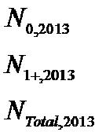

Table 3.3.3.1.6 Catch options with relative population size (D1+) and 95% confidence intervals over 10 years for harp seals in the Greenland Sea. The model with historical reproduction parameters is used when evaluating these catch options.

Catch option | Proportion pups in Pup catch |  | Age 1+ | Total catch | D1+
 | catches |  | catch |  | (95% CI)
Current level | 59.9% | 3 557 | 2 384 | 5 941 | 1.06 | 1.21 | 1.36
Equilibrium | 59.9% | 12 237 | 8 192 | 20 429 | 0.82 | 1.00 | 1.18
Equilibrium | 0% | 0 | 14 600 | 14 600 | 0.82 | 1.00 | 1.18
Reduce to N₇₀ ª | 59.9% | 18 562 | 12 426 | 30 988 | 0.64 | 0.85 | 1.06
Reduce to N₇₀ª | 0% | 0 | 21 270 | 21 270 | 0.67 | 0.87 | 1.07

6 ICES Advice 2013, Book 3
White Sea/Barents Sea harp seals

State of stock/exploitation

Due to concern over the decline in harp seal pup production in the White Sea since 2004, ICES (2011a) recommended that removals be restricted to a level predicted to maintain a stable population size. This sustainable equilibrium catch number was estimated at 15 827 age 1+ animals (where two pups balance one age 1+ animal) in the White and Barents seas in 2012 and 2013. The Joint Norwegian–Russian Fisheries Commission followed this request and allocated 7000 seals of this TAC to Norway in both years. The Russian hunt was intending to focus on beaters but as a result of the Russian ban on catches of harp seals less than 1 year of age that has been in place since 2009, there were no commercial Russian harp seal catches in the White Sea in 2012 or 2013. Local hunters caught nine adult seals for subsistence use in 2012. No Norwegian vessels hunted in this area in 2012 or 2013 (Table 3.3.3.1.7).

Population assessment

Pup production

Aerial surveys were conducted in 2013 to estimate pup production in the White Sea using the same multi-spectral methods that have been used in the past (Figure 3.3.3.1.3; ICES, 2013). Six survey flights produced two independent estimates. Ice conditions in 2013 were typical, corresponding to long-term, mean ice conditions. Pup production estimates will be available in 2014. Taking into account the uncertainties in the trend of pup production for this population, ICES recommends that the results should be presented for review as soon as possible.

Population estimates

An age-structured population dynamics model developed to estimate abundance and provide catch options for harp seals in the White Sea/Barents Sea was presented to the working group (ICES, 2013). It incorporates time-varying reproductive rates (Tables 3.3.3.1.8 and 3.3.3.1.9; Figure 3.3.3.1.4) , estimates of pup production (Table 3.3.3.1.10) and historical catch data (Table 3.3.3.1.7) to estimate the current total population. The model also estimates the initial population size (N₀), pup mortality (M₀), and mortality of all seals aged 1 year and older (M₁₊).

The estimated population sizes, along with the parameters for the priors used are presented in Table 3.3.3.1.11, and the modelled population trajectory is shown in Figure 3.3.3.1.5. The model fit to the observed pup production estimates is poor. The modelled total population indicates that the harp seal abundance in the White Sea decreased from 1946 to the early 1960s, but has generally increased since then. The modelled total population in 2013 is estimated to be about 83% of N_{max}, which is the historical maximum population size estimated.

Catch options

The estimates for the various catch options are given in Table 3.3.3.1.12. If the recent average catch (2008–2012) of 2732 animals (97.6% pups) is maintained, the stock is expected to increase by 13% over ten years. However, ICES notes that the catches in 2009–2012 have been 200 animals or lower, and the actual increase rate will be higher if catches continue at this level.

The estimated equilibrium (sustainable) catch level would be 32 736 animals (97.6% pups) or 17 400 (100% age 1+ animals). A catch level of 49 775 (97.6% pups) or 26 650 (100% age1+ animals) will reduce the population size to N₇₀ with a probability of 80% within ten years. Because the stock is considered to be data poor, PBR was also calculated. The PBR removals are estimated at 40 430 animals (14% pups). This catch option indicates a 16% reduction of the age 1+ population in ten years.

ICES is concerned about the high removals and declining population that would result from using the PBR approach and also the lack of fit of the model to the pup production estimates. In conclusion ICES advises that the estimated equilibrium catches are the preferred option and that additional modelling approaches should be explored to improve the fit. The current equilibrium option is slightly higher than the option given in 2011. This is likely a result of the minimal catches in 2012 and 2013.

Simulation work conducted on the Northwest Atlantic harp seal population suggests that catches should be projected over a period of at least 15 years to determine their impact on the population. Therefore, ICES advises that future catch scenarios are explored over a 15-year period, rather than the current ten years. This advice applies to all of the populations considered by ICES.

ICES Advice 2013, Book 3 | 7

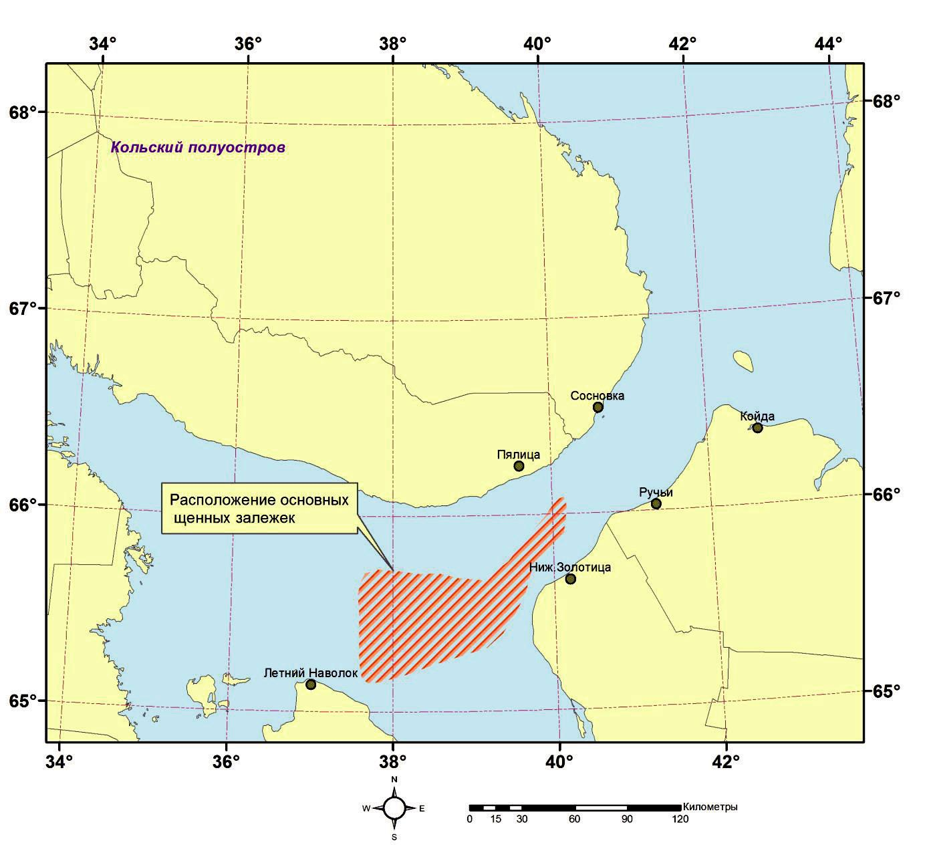

Figure 3.3.3.1.3 Location of the harp seal whelping patch in the White Sea.
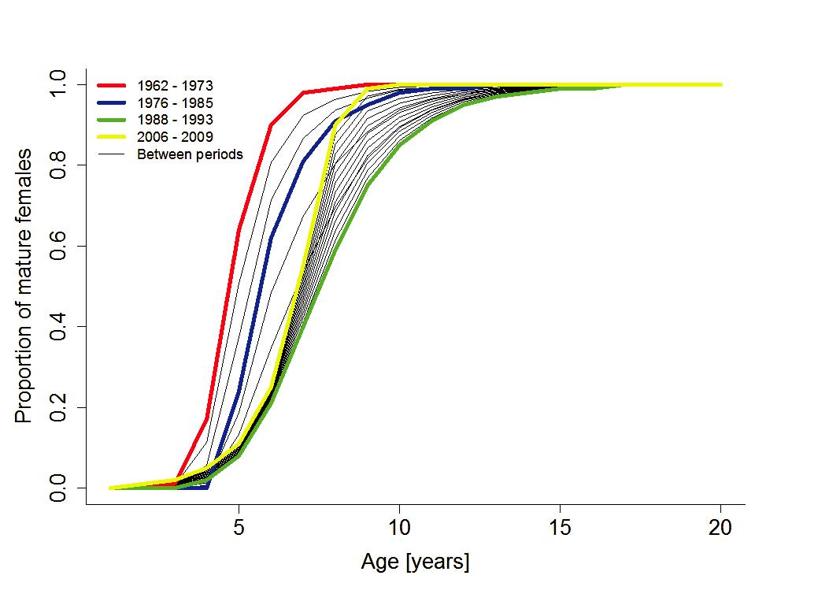

Figure 3.3.3.1.4 Proportion of mature females among harp seals in the East Ice in four periods. Values are taken from Table 3.3.3.1.1.

8 ICES Advice 2013, Book 3
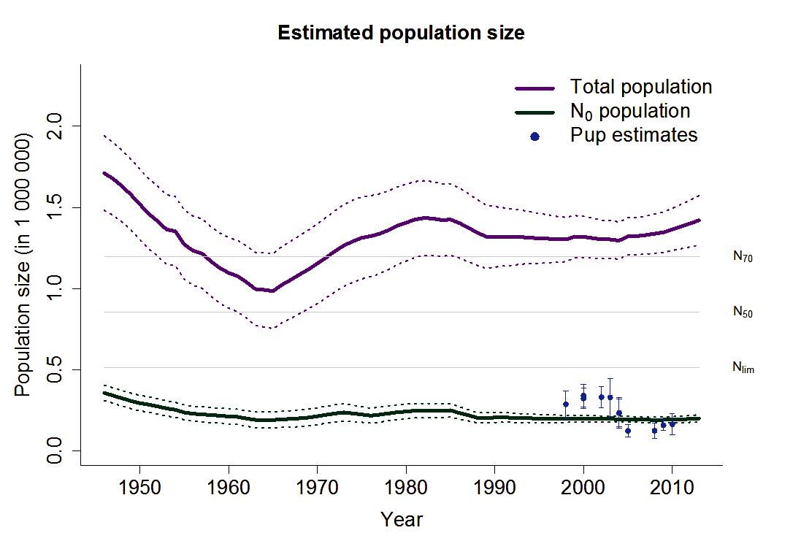

Figure 3.3.3.1.5 Modelled Barents Sea/White Sea harp seal population trajectories for pups and total population (full lines)

and 95% confidence intervals (dashed lines). N₇₀, N₅₀, and N_{lim} denote the 70%, 50%, and 30% of the historical maximum population size, respectively.

Table 3.3.3.1.7 |  | Annual catches of harp seals in the White and Barents seas (“East Ice”), 1946–2008^{a,b}.
Year |  | Norwegian catches |  |  | Russian catches |  |  |  | Total catches
 | Pups |  | 1 year and | Total | Pups | 1 year and | Total | Pups | 1 year and | Total
 |  |  | older |  |  | older |  |  | older
1946–50 |  |  |  | 25057 | 90031 | 55285 | 145316 |  |  | 170373
1951–55 |  |  |  | 19590 | 59190 | 65463 | 124653 |  |  | 144243
1956–60 |  | 2278 | 14093 | 16371 | 58824 | 34605 | 93429 | 61102 | 48698 | 109800
1961–65 |  | 2456 | 8311 | 10767 | 46293 | 22875 | 69168 | 48749 | 31186 | 79935
1966–70 |  |  |  | 12783 | 21186 | 410 | 21596 |  |  | 34379
1971 |  | 7028 | 1596 | 8624 | 26666 | 1002 | 27668 | 33694 | 2598 | 36292
1972 |  | 4229 | 8209 | 12438 | 30635 | 500 | 31135 | 34864 | 8709 | 43573
1973 |  | 5657 | 6661 | 12318 | 29950 | 813 | 30763 | 35607 | 7474 | 43081
1974 |  | 2323 | 5054 | 7377 | 29006 | 500 | 29506 | 31329 | 5554 | 36883
1975 |  | 2255 | 8692 | 10947 | 29000 | 500 | 29500 | 31255 | 9192 | 40447
1976 |  | 6742 | 6375 | 13117 | 29050 | 498 | 29548 | 35792 | 6873 | 42665
1977 |  | 3429 | 2783 | 6212^{c} | 34007 | 1488 | 35495 | 37436 | 4271 | 41707
1978 |  | 1693 | 3109 | 4802 | 30548 | 994 | 31542 | 32341 | 4103 | 36344
1979 |  | 1326 | 12205 | 13531 | 34000 | 1000 | 35000 | 35326 | 13205 | 48531
1980 |  | 13894 | 1308 | 15202 | 34500 | 2000 | 36500 | 48394 | 3308 | 51702
1981 |  | 2304 | 15161 | 17465^{d} | 39700 | 3866 | 43566 | 42004 | 19027 | 61031
1982 |  | 6090 | 11366 | 17456 | 48504 | 10000 | 58504 | 54594 | 21366 | 75960
1983 |  | 431 | 17658 | 18089 | 54000 | 10000 | 64000 | 54431 | 27658 | 82089
1984 |  | 2091 | 6785 | 8876 | 58153 | 6942 | 65095 | 60244 | 13727 | 73971
1985 |  | 348 | 18659 | 19007 | 52000 | 9043 | 61043 | 52348 | 27702 | 80050
1986 |  | 12859 | 6158 | 19017 | 53000 | 8132 | 61132 | 65859 | 14290 | 80149
1987 |  | 12 | 18988 | 19000 | 42400 | 3397 | 45797 | 42412 | 22385 | 64797
1988 |  | 18 | 16580 | 16598 | 51990 | 2501e | 54401 | 51918 | 19081 | 70999
ICES Advice 2013, Book 3 |  |  |  |  |  |  |  |  |  | 9
Year | Norwegian catches |  |  | Russian catches |  |  |  | Total catches
 | Pups | 1 year and | Total | Pups | 1 year and | Total | Pups |  | 1 year and | Total
 |  | older |  |  | older |  |  |  | older
1989 | 0 | 9413 | 9413 | 30989 | 2475 | 33464 | 30989 |  | 11888 | 42877
1990 | 0 | 9522 | 9522 | 30500 | 1957 | 32457 | 30500 |  | 11479 | 41979
1991 | 0 | 9500 | 9500 | 30500 | 1980 | 32480 | 30500 |  | 11480 | 41980
1992 | 0 | 5571 | 5571 | 28351 | 2739 | 31090 | 28351 |  | 8310 | 36661
1993 | 0 | 8758^{f} | 8758 | 31000 | 500 | 31500 | 31000 |  | 9258 | 40258
1994 | 0 | 9500 | 9500 | 30500 | 2000 | 32500 | 30500 |  | 11500 | 42000
1995 | 260 | 6582 | 6842 | 29144 | 500 | 29644 | 29404 |  | 7082 | 36486
1996 | 2910 | 6611 | 9521 | 31000 | 528 | 31528 | 33910 |  | 7139 | 41049
1997 | 15 | 5004 | 5019 | 31319 | 61 | 31380 | 31334 |  | 5065 | 36399
1998 | 18 | 814 | 832 | 13350 | 20 | 13370 | 13368 |  | 834 | 14202
1999 | 173 | 977 | 1150 | 34850 | 0 | 34850 | 35023 |  | 977 | 36000
2000 | 2253 | 4104 | 6357 | 38302 | 111 | 38413 | 40555 |  | 4215 | 44770
2001 | 330 | 4870 | 5200 | 39111 | 5 | 39116 | 39441 |  | 4875 | 44316
2002 | 411 | 1937 | 2348 | 34187 | 0 | 34187 | 34598 |  | 1937 | 36535
2003 | 2343 | 2955 | 5298 | 37936 | 0 | 37936 | 40279 |  | 2955 | 43234
2004 | 0 | 33 | 33 | 0 | 0 | 0 | 0 |  | 33 | 33
2005 | 1162 | 7035 | 8197 | 14258 | 19 | 14277 | 15488 |  | 9405 | 22474
2006 | 147 | 9939 | 10086 | 7005 | 102 | 7107 | 7152 |  | 10041 | 17193
2007 | 242 | 5911 | 6153 | 5276 | 200 | 5476 | 5518 |  | 6111 | 11629
2008 | 0 | 0 | 0 | 13331 | 0 | 13331 | 13331 |  | 0 | 13331
2009 | 0 | 0 | 0 | 0 | 0 | 0 | 0 |  | 0 | 0
2010 | 0 | 105 | 105 | 5 | 5 | 10 | 5 |  | 110 | 115
2011 | 0 | 200 | 200 | 0 | 0 | 0 | 0 |  | 200 | 200
2012 | 0 | 0 | 0 | 0 | 9 | 9 | 0 |  | 9 | 9
2013 | 0 | 0 | 0 | 0 | 0 | 0 | 0 |  | 0 | 0

- The period 1946–1970 shows only five-year averages.
- Incidental catches of harp seals in fishing gear on Norwegian and Murmansk coasts are not included.
- Approx. 1300 harp seals (unspecified age) caught by a ship which was lost are not included.
- An additional 250–300 animals were shot but lost as they drifted into Soviet territorial waters.
- Russian catches of age 1+ animals after 1987 selected by scientific sampling protocols.
- Included 717 seals caught to the south of Spitsbergen, east of 14°E, by a ship operating mainly in the Greenland Sea.

Table 3.3.3.1.8 | Estimates of proportion of mature females giving birth. Data from ICES (2011a).
 |  |  | Year | Estimated F
 |  |  | 1990–1993 | 0.84
 | 2006 |  |  | 0.68

Table 3.3.3.1.9 |  |  | Estimates of proportions of mature females (p) at ages 4–13 in four historical periods: P₁ = 1962–1972; P₂ =
 |  |  | 1976–1985; P₃ = 1988–1993; P₄ = 2006–2009. Data from ICES (2011a).
Age | 2 | 3 | 4 | 5 | 6 | 7 | 8 | 9 | 10 | 11 | 12 | 13 | 14 | 15
P₁ | 0 | 0.01 | 0.17 | 0.64 | 0.90 | 0.98 | 0.99 | 1.0 | 1.0 | 1.0 | 1.0 | 1.0 | 1.0 | 1.0
P₂ | 0 | 0 | 0 | 0.24 | 0.62 | 0.81 | 0.81 | 0.95 | 0.98 | 0.99 | 0.99 | 1.0 | 1.0 | 1.0
P₃ | 0 | 0 | 0.02 | 0.08 | 0.21 | 0.40 | 0.59 | 0.75 | 0.85 | 0.91 | 0.95 | 0.97 | 0.98 | 0.99
P₄ | 0.01 | 0.02 | 0.05 | 0.11 | 0.25 | 0.55 | 0.90 | 0.99 | 1.0 | 1.0 | 1.0 | 1.0 | 1.0 | 1.0

10 ICES Advice 2013, Book 3
Table 3.3.3.1.10 Timing of Russian surveys, estimated numbers of pups and coefficients of variation (CV) in the White Sea/Barents Sea. Numbers and CVs are drawn from ICES (2011b).

Year | Survey period |  | Estimated number | Coefficient of
 |  |  | of pups | variation
1998 | 12 | & 16 March | 286 260 | 0.150
2000 | 10–12 March-photo |  | 322 474ª | 0.098
 | 18 | March-multispectral | 339 710^{b} | 0.105
2002 | 20 | March | 330 000 | 0.103
2003 | 18 | & 21 March | 328 000^{c} | 0.181
2004 | 22 | March – photo | 231 811 | 0.190
 | 22 | March-multispectral | 234 000 | 0.205
2005 | 23 | March | 122 658 | 0.162
2008 | 19–20 March |  | 123 104 | 0.199
2009 | 14–16 March |  | 157 000 | 0.108
2010 | 20–23 March |  | 163 022 | 0.198

ªFirst 2000 estimates represented the sum of 291 745 pups (SE = 28 708) counted plus a catch 30 729 prior to the survey for a total pup production of 322 474.

^{b}Second 2000 estimate represents the sum of 308 981pups (SE = 32 400) counted plus a catch of 30 729 prior to the survey for a total pup production of 339 710.

^{c}2003 estimate represents the sum of 298 000 pups (SE = 53 000) counted, plus a catch of 35 000 prior to the survey for a total pup production of 328 000.

Table 3.3.3.1.11 Estimated mean values and standard deviations of the parameters used in the model. Priors used are shown in brackets.

 | Parameters | Model estimates
 | Parameters | Mean |  | SD
 | ^{N}t₀ | 1 354 376 |  | 116 050
 | ^{N}t₀ | (1 000 000) |  | (2 000 000)
 | M0 | 0.33 | (0.27) | 0.05
 |  |  |  | (0.05)
 | M1+ | 0.11 | (0.09) | 0.01
 |  |  |  | (0.008)
 |  | 198 800 |  | 11 565
 |  | 1 221 000 |  | 77 143
 |  | 1 419 800 |  | 78 005

Table 3.3.3.1.12 Catch options with relative age 1+ population size (D1+) in ten years (2023) for harp seals in the White Sea.

Catch option | Proportion | Pup | Age 1+ | Total | D1+
 | pups in | catch | catch | catch | (95% CI)
 | catches
Current level | 97.6% | 2 667 | 65 | 2 732 | 1.01 | 1.13 | 1.25
Equilibrium | 97.6% | 31 950 | 786 | 32 736 | 0.88 | 1.00 | 1.12
Equilibrium | 0% | 0 | 17 400 | 17 400 | 0.88 | 1.00 | 1.12
Reduce to N₇₀ ^{a)} | 97.6% | 48 580 | 1 195 | 49 775 | 0.81 | 0.93 | 1.05
Reduce to N₇₀^{a)} | 0% | 0 | 26 650 | 26 650 | 0.81 | 0.93 | 1.05
PBR^{b)} | 14.0% | 5 660 | 34 770 | 40 430 | 0.71 | 0.84 | 0.96

ªCatches that would reduce the population to 70% of current level with a 0.8 probability over ten years. ^{b}PBR catch is evenly distributed across all age groups.

ICES Advice 2013, Book 3 | 11

Greenland Sea hooded seals

State of stock/exploitation

Concerns over low pup production estimates resulted in advice from ICES that no harvest of Greenland Sea hooded seals should be permitted, with the exception of catches for scientific purposes, since 2007. This advice was immediately implemented. Total catches for scientific purposes (all taken by Norway) in 2012 and 2013 (Table 3.3.3.1.13) were 21 (including 15 pups) and 22 (including 15 pups), respectively. Subsistance catches from northeast Greenland have only averaged five animals per year during 2006–2011, which is about 20% of the 1993–2005 average.

Population estimates

No distinct hooded seal whelping concentrations were detected during the Norwegian survey of the Greenland Sea carried out in 2012. Covering a relatively large area the survey detected only scattered hooded seal families and, subsequently, solitary bluebacks. The hooded seals were mixed with harp seals in the whelping patch covered by the photographic survey carried out 28 March. Results from the staging flights suggest that the majority of hooded seal females whelped between 20 and 29 March, peaking on 24 March 2012. After correcting for the estimated temporal distribution of births the total estimate of hooded seal pup production was 13 655 (SE = 1 900), which is lower than estimates obtained from comparable surveys in 2005 and 2007, but the differences were not significant. The extensive reconnaissance surveys of all areas historically used by hooded seals in the Greenland Sea reduced the likelihood of missing major whelping concentrations in 2012. Difficult weather conditions meant that a small number of pups may not have been surveyed in the very open ice fringes northeast of the survey area, but this is not considered to be significant.

Results from the 2012 pup survey suggest that pup production remains low and that production in 2012 was significantly lower than observed in the 1997 survey (23 762 pups, SE = 4562; Table 3.3.3.1.14). ICES noted that the estimates reported for the 1997 and 2005 surveys in previous WG reports were incorrect.

The population model used to assess the stock size is similar to the model used to assess the Barents Sea/White Sea harp seal population. The model uses empirically derived maturity curves and was run for three different scenarios of pregnancy rates, F = 0.5, F = 0.7, and F = 0.9 (Table 3.3.3.1.15; Figure 3.3.3.1.6). Recent analyses indicate that pregnancy rates remained constant around F = 0.7 in the period 1958–1999. This is lower than the estimate of F = 0.9 used by ICES in its 2011 report (ICES, 2011b). The difference resulted from a change in the method used to determine pregnancy rates. Under the scenario of F = 0.7 the model estimates a 2013 pup production of 14 010 (SE = 1622) and an age 1+ population of 68 820 (SE = 7862), giving a total population of 82 830 (SE = 8028), and the model furthermore predicts a 7% decrease of the age 1+ population over the next ten years. As a result of incorporating the most recent pup production estimates, the population estimates from the model were lower than the ones obtained in 2011 (ICES, 2011b).

Catch options

The stock is estimated to be well below N_{lim}. Since 2008 ICES has recommended that there be no catch of Greenland Sea hooded seals. ICES continues to advise that there should be no catch of Greenland Sea hooded seals.

12 ICES Advice 2013, Book 3
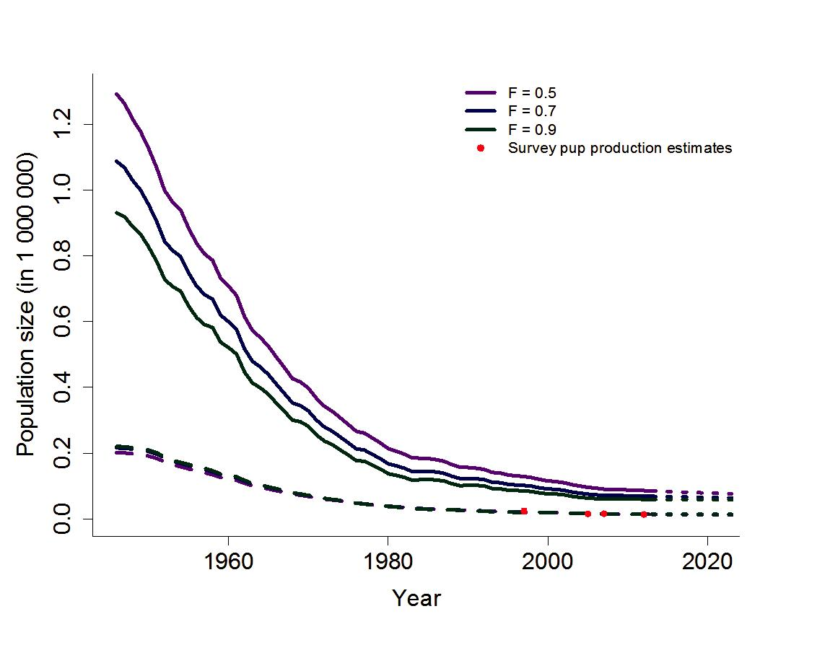

Figure 3.3.3.1.6 Modelled hoodel seal population trajectories for pups (dashed lines) and age 1+ population (full lines) and 95% confidence intervals (dotted lines). Red dots represent pup survey estimates.

Table 3.3.3.1.13 Catches of hooded seals in the Greenland Sea (“West Ice”) from 1946 through 2013ª. Totals include catches for scientific purposes.

Year | Norwegian catches |  |  |  | Russian catches |  |  |  |  | Total catches
 | Pups | 1 year |  | Total | Pups | 1 year |  | total | Pups |  | 1 year |  | Total
 |  | and older |  |  |  | and older |  |  |  |  | and older
1946–50 | 31152 | 10257 |  | 41409 | - | - |  | - | 31152 |  | 10257 |  | 41409
1951–55 | 37207 | 17222 |  | 54429 | - | - |  | -^{b} | 37207 |  | 17222 |  | 54429
1956–60 | 26738 | 9601 |  | 36339 | 825 | 1063 |  | 1888^{b} | 27563 |  | 10664 |  | 38227
1961–65 | 27793 | 14074 |  | 41867 | 2143 | 2794 |  | 4937 | 29936 |  | 16868 |  | 46804
1966–70 | 21495 | 9769 |  | 31264 | 160 | 62 |  | 222 | 21655 |  | 9831 |  | 31486
1971 | 19572 | 10678 |  | 30250 | - | - |  | - | 19572 |  | 10678 |  | 30250
1972 | 16052 | 4164 |  | 20216 | - | - |  | - | 16052 |  | 4164 |  | 20216
1973 | 22455 | 3994 |  | 26449 | - | - |  | - | 22455 |  | 3994 |  | 26449
1974 | 16595 | 9800 |  | 26395 | - | - |  | - | 16595 |  | 9800 |  | 26395
1975 | 18273 | 7683 |  | 25956 | 632 | 607 |  | 1239 | 18905 |  | 8290 |  | 27195
1976 | 4632 | 2271 |  | 6903 | 199 | 194 |  | 393 | 4831 |  | 2465 |  | 7296
1977 | 11626 | 3744 |  | 15370 | 2572 | 891 |  | 3463 | 14198 |  | 4635 |  | 18833
1978 | 13899 | 2144 |  | 16043 | 2457 | 536 |  | 2993 | 16356 |  | 2680 |  | 19036
1979 | 16147 | 4115 |  | 20262 | 2064 | 1219 |  | 3283 | 18211 |  | 5334 |  | 23545
1980 | 8375 | 1393 |  | 9768 | 1066 | 399 |  | 1465 | 9441 |  | 1792 |  | 11233
1981 | 10569 | 1169 |  | 11738 | 167 | 169 |  | 336 | 10736 |  | 1338 |  | 12074
1982 | 11069 | 2382 |  | 13451 | 1524 | 862 |  | 2386 | 12593 |  | 3244 |  | 15837
1983 | 0 | 86 |  | 86 | 419 | 107 |  | 526 | 419 |  | 193 |  | 612
1984 | 99 | 483 |  | 582 | - | - |  | - | 99 |  | 483 |  | 582
1985 | 254 | 84 |  | 338 | 1632 | 149 |  | 1781 | 1886 |  | 233 |  | 2119
1986 | 2738 | 161 |  | 2899 | 1072 | 799 |  | 1871 | 3810 |  | 960 |  | 4770
1987 | 6221 | 1573 |  | 7794 | 2890 | 953 |  | 3843 | 9111 |  | 2526 |  | 11637
1988 | 4873 | 1276 |  | 6149^{c} | 2162 | 876 |  | 3038 | 7035 |  | 2152 |  | 9187
ICES Advice 2013, Book 3 |  |  |  |  |  |  |  |  |  |  |  |  | 13
Year | Norwegian catches |  |  |  | Russian catches |  |  |  |  | Total catches
 | Pups | 1 year |  | Total | Pups | 1 year |  | total | Pups |  | 1 year |  | Total
 |  | and older |  |  |  | and older |  |  |  |  | and older
1989 | 34 | 147 |  | 181 | - | - |  | - | 34 |  | 147 |  | 181
1990 | 26 | 397 |  | 423 | 0 | 813 |  | 813 | 26 |  | 1210 |  | 1236
1991 | 0 | 352 |  | 352 | 458 | 1732 |  | 2190 | 458 |  | 2084 |  | 2542
1992 | 0 | 755 |  | 755 | 500 | 7538 |  | 8038 | 500 |  | 8293 |  | 8793
1993 | 0 | 384 |  | 384 | - | - |  | - | 0 |  | 384 |  | 384
1994 | 0 | 492 |  | 492 | 23 | 4229 |  | 4252 | 23 |  | 4721 |  | 4744
1995 | 368 | 565 |  | 933 | - | - |  | - | 368 |  | 565 |  | 933
1996 | 575 | 236 |  | 811 | - | - |  | - | 575 |  | 236 |  | 811
1997 | 2765 | 169 |  | 2934 | - | - |  | - | 2765 |  | 169 |  | 2934
1998 | 5597 | 754 |  | 6351 | - | - |  | - | 5597 |  | 754 |  | 6351
1999 | 3525 | 921 |  | 4446 | - | - |  | - | 3525 |  | 921 |  | 4446
2000 | 1346 | 590 |  | 1936 | - | - |  | - | 1346 |  | 590 |  | 1936
2001 | 3129 | 691 |  | 3820 | - | - |  | - | 3129 |  | 691 |  | 3820
2002 | 6456 | 735 |  | 7191 | - | - |  | - | 6456 |  | 735 |  | 7191
2003 | 5206 | 89 |  | 5295 | - | - |  | - | 5206 |  | 89 |  | 5295
2004 | 4217 | 664 |  | 4881 | - | - |  | - | 4217 |  | 664 |  | 4881
2005 | 3633 | 193 |  | 3826 | - | - |  | - | 3633 |  | 193 |  | 3826
2006 | 3079 | 568 |  | 3647 |  |  |  |  | 3079 |  | 568 |  | 3647
2007 | 27 | 35 |  | 62 |  |  |  |  | 27 |  | 35 |  | 62
2008 | 9 | 35 |  | 44 |  |  |  |  | 9 |  | 35 |  | 44
2009 | 396 | 17 |  | 413 |  |  |  |  | 396 |  | 17 |  | 413
2010 | 14 | 164 |  | 178 |  |  |  |  | 14 |  | 164 |  | 178
2011 | 15 | 4 |  | 19 |  |  |  |  | 15 |  | 4 |  | 19
2012 | 15 | 6 |  | 21 |  |  |  |  | 15 |  | 6 |  | 21
2013 | 15 | 7 |  | 22 |  |  |  |  | 15 |  | 7 |  | 22

- The period 1946–1970 shows only five-year averages.
- For 1955, 1956, and 1957 Soviet catches of harp and hooded seals combined are reported at 3900, 11 600, and 12 900, respectively. These catches are not included.
- Including 1048 pups and 435 adults caught by a ship which was lost.

Table 3.3.3.1.14 Survey estimates of Greenland Sea hooded seal pup production.

Year | Estimate | c.v.
1997 | 23 762 | 0.192
2005 | 15 250 | 0.228
2007 | 16 140 | 0.133
2012 | 13 655 | 0.138

14 ICES Advice 2013, Book 3
Table 3.3.3.1.15 Model estimates and standard deviation of the parameters used in the model for the original and for various choices of the reproductive rate F. Priors used are shown in brackets. D is the ratio of the projected 2021 population to the current population.

Parameters | F = 0.5 |  | F = 0.7 |  | F = 0.9
Parameters | Mean | SD | Mean | SD | Mean | SD
^{N}t₀ | 1 290 620 | 459 220 | 1 086 890 | 394 940 | 930 610 | 337 060
^{N}t₀ | (90000) | (90000)
M₀ | (90000) | (90000)
M₀ | 0.33 | 0.05 | 0.34 | 0.02 | 0.34 | 0.05
M1+ | (0.33) | (0.05)
M1+ | 0.14 | 0.02 | 0.17 | 0.05 | 0.19 | 0.02
 | (0.11) | (0.05)
 | 13 850 | 1 548 | 14 010 | 1 622 | 14 230 | 1 680
 | 85 220 | 9 427 | 68 820 | 7 862 | 59 700 | 6 937
 | 99 070 | 9 553 | 82 830 | 8 028 | 73 930 | 7 137
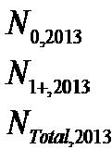

Sources of information

ICES. 2011a. Norwegian request on status and harvest potential of the Harp seal stocks in the Greenland Sea and the White Sea/Barents Sea, and of the Hooded seal stock in the Greenland Sea. In Report of the ICES Advisory Committee, 2011. Section 3.3.3.2 in ICES Advice 2011, Book 3: 7–21.

ICES. 2011b. Report of the Working Group on Harp and Hooded Seals (WGHARP), 15–19 August 2011, St Andrews, Scotland, UK. ICES CM 2011/ACOM:22. 78 pp.

ICES. 2013. Report of the Working Group on Harp and Hooded Seals (WGHARP), 26–30 August 2013, PINRO, Murmansk, Russia. ICES CM 2013/ACOM:20. 59 pp.

ICES Advice 2013, Book 3 | 15

